What’s the Difference Between Medicare vs Medicaid?
May 24, 2022

When it comes time to explore the different paths of government subsidized healthcare it can be confusing to navigate. Oftentimes, Medicare and Medicaid can become tangled in this process. Here’s how to identify the differences so you can pursue the option right for you.

What is Medicare?
Medicare is a federal insurance program that provides health coverage beginning at 65 years old or if you are under 65 and have a disability. There are four different parts of Medicare that users can choose to partake in, Part A: hospitalization coverage, Part B: medical insurance, Part C: advantage plans, and Part D: prescription drug coverage. Part A and B are available for no out of pocket expense. This is unlike Part C and Part D that require an out-of-pocket expense since they are through privatized healthcare organizations. Medicare is right that each United States citizen receives at the age of 65.

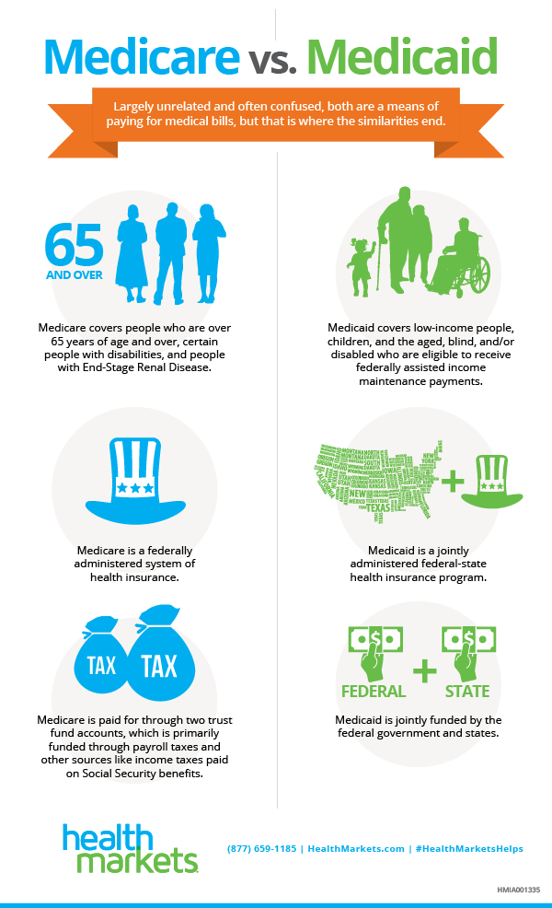

What is Medicaid?
Medicaid is an assistance program for those below the poverty level. A large difference between the two is that Medicare coverage is not determined by your income whereas Medicaid requires your income for qualification. Medicaid is a state and federal assistance program that provides health coverage for those that have an income below poverty level. Since Medicaid is an assistance program there no cost to the user for services covered by Medicaid. The mandated services offered and covered by Medicaid include: Hospitalization, Laboratory services, X-rays, Doctor services, Family planning, Nursing services, Nursing facility services, home healthcare for people eligible for nursing facility services, Clinic treatment, Pediatric and family nurse practitioner services, and Midwife services. Medicaid is also often used to fund long-term care, which is not covered by Medicare or most private health insurance policies. Be mindful that Medicaid’s coverage requirements can vary state to state.

Is Medicare or Medicaid a better option for you?
If you are a retiree or soon to be retiree age 65 or older you are more than likely looking to pursue Medicare plans for your future healthcare needs. However, if your income is below the poverty line it would be a wiser choice to apply for Medicaid assistance instead as it requires no out of pocket costs to you. The big difference for you is Medicare is a federal insurance program whereas Medicaid is a state and federal assistance program.

Michaela Dowdy

